Design Phase Report
Title: Hardware company database

List of Team Members: Omkar Kamble, Rahul Thakur, Vivek Kumar, Sidhant Chaturwedi
Team Leader: Vivek Kumar

Responsibilities:
- Vivek Kumar: ER diagram & Schema with Join Queries
- Rahul Thakur: Table creation & Sub-Queries
- Sidhant Chaturwedi: Data Insertion & Arithmetic Queries
- Omkar Kamble: Data Insertion & SQL Queries

Requirements Specification:
- A quote with a start date in the past cannot be activated.
- A quote is available only for 30 days after its creation.
- Sale orders (type 3 & Order call table) don’t need a start date/end date.
[if there is a change in your earlier requirements mention the changes, be clear with functional/module level requirements]

Design Questions to be answered
[Note: Complete a logical design of a database. This section of the course project involves designing a database schema based on problem specification stated during proposal phase. Here, you need to submit a report summarizing your design which includes Entity-Relationship Model, ER to Relational mapping, data dictionary, data flow diagram,Normalization.
Question 1: From the problem description, identify the entities that need to be represented in the database, the attributes of each entity, the relationships between the entities, and the cardinality ratios of each relationship.
Entities:
Sales-person, Customer, Contact-person, Onsite-support, Engineer, Product, Supplier, Order, Order-line
Diagrams of individual relationships:
One sales person is assigned many customers, and many customers are assigned to one sales person; a sales person can exist without having a customer assigned, but there is no customer without a sales person assigned, this being an optional to mandatory relationship.
- Sales-person(1)-is assigned-Customers(M)
One customer can have many ordering contacts, but one ordering contact is assigned to only one customer; one ordering contact cannot exist without a customer, but a customer can exist without having an ordering contact (it didn’t make any order request); this is an optional to mandatory relationship.
- Customer(1)-is assigned-Ordering Contracts(M)
One ordering contact can make many orders, but one order can have only one ordering contact; one ordering contact can be registered in the database without having an order, but an order cannot be registered without an ordering contact.
- Ordering Contract(1)-makes-Orders(M)
One order can have many order lines, while an order line is linked to only one order; the order cannot exist without the order line and the order line cannot exist without the order- this is a mandatory-to-mandatory relationship.
- Order Call(1)-detailed-Order Line(M)
One product is present on many order lines, while many order lines have only one product; an order line must have a product, while a product can exist without having an order line- this is a mandatory to optional relationship.
- Order Line(M)-contains-Product(1)
One supplier provides only one product line, while one product line is provided by only one supplier; it is mandatory for a supplier to provide a product line, and it is mandatory for a product line to have a supplier – this is a mandatory to mandatory relationship.
- Supplier(1)-provides-Product(1)
Many engineers are specialized in many different products and many products have many engineers with a specialization; an engineer might exist without having a specialization in a product line but having a general specialization, while product can exist as well without having an engineer specialized in the product line – this is an optional-to-optional relationship.
- Engineer(M)-specialized-Products(M)
One engineer can provide many onsite support services, but an onsite support service is delivered by one engineer; an engineer can exist without having an onsite support, but an onsite support service cannot exist without an engineer – this is an optional to mandatory relationship.
- Engineer(1)-provides-Onsite Support(M)
One customer can have many onsite supports, but an onsite support can have only one customer; a customer can exist without having an onsite support, but an onsite support must have a customer, this being an optional to mandatory relationship.
- Customer(1)-requests-Onsite Support(M)
Question 2: Draw an Entity-Relationship Diagram illustrating the information you have identified in Question 1.
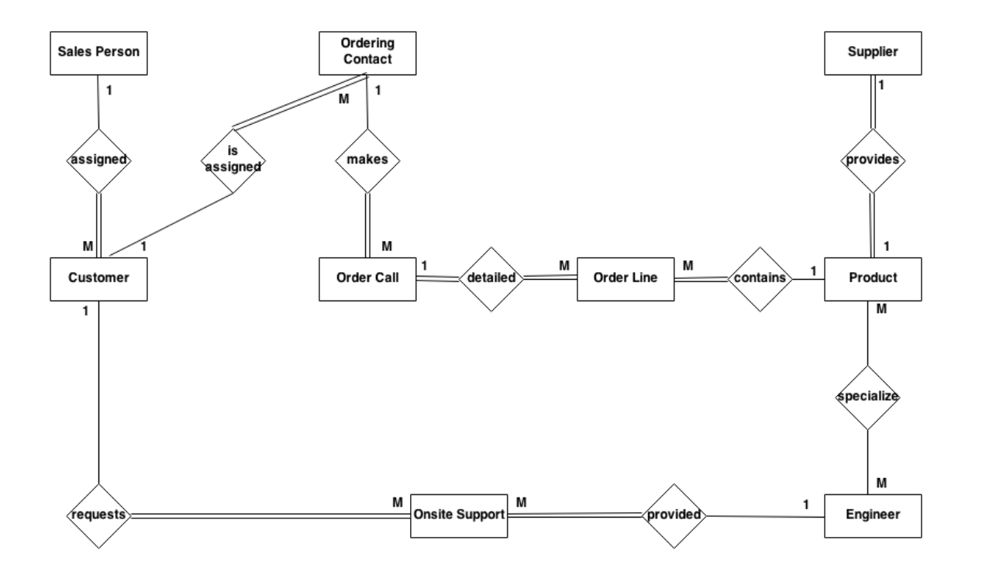
Question 3: Draw alternate Entity-Relationship Diagram illustrating the information you have identified in Question 1 that you think are most likely to occur.
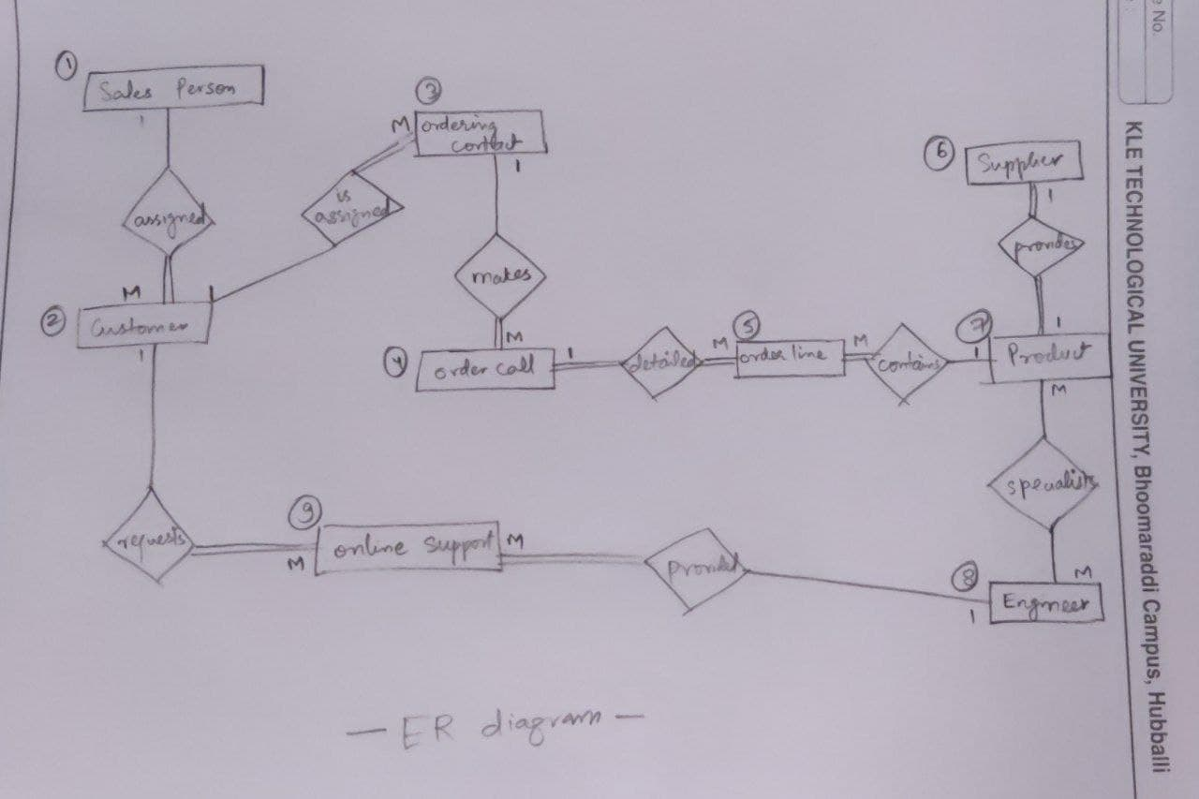
Repeat Question 3 if you have many alternate ER designs.
Question 4: Choose the optimal Entity-Relationship Diagram from the designs provided above and justify why you think this is an optimal solution for your identified problem specification.
- We choose the first Entity-Relationship Diagram as it gives clarity of all the relationships among the entities.
- It also helps us in identifying the primary & foreign key of each entity and build proper connection among them.
[Optional] Question 5: Draw an Object Model illustrating the information you have identified in Question 2.
Question 6: Draw an ER to Relation Mapping illustrating the information you have identified in Question 4.
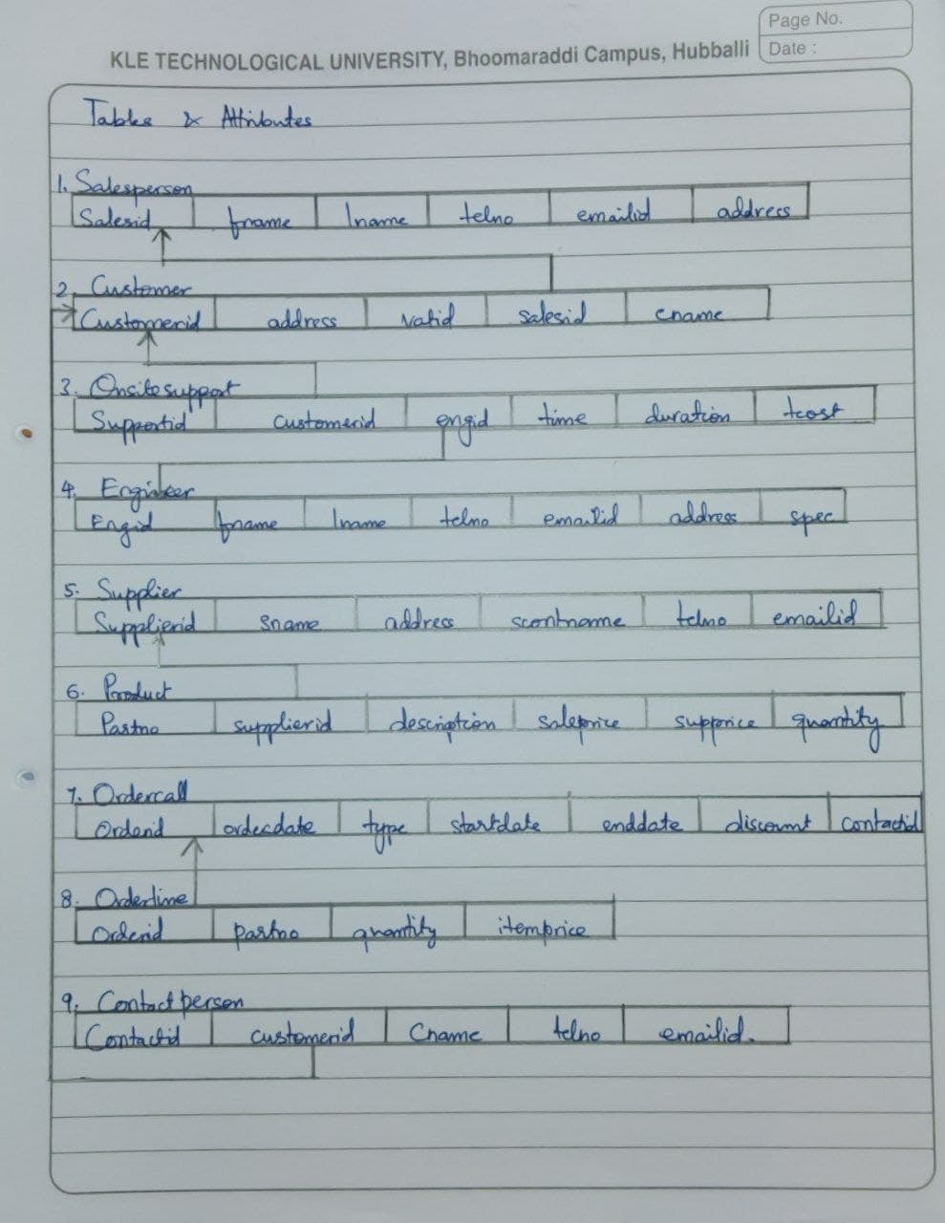
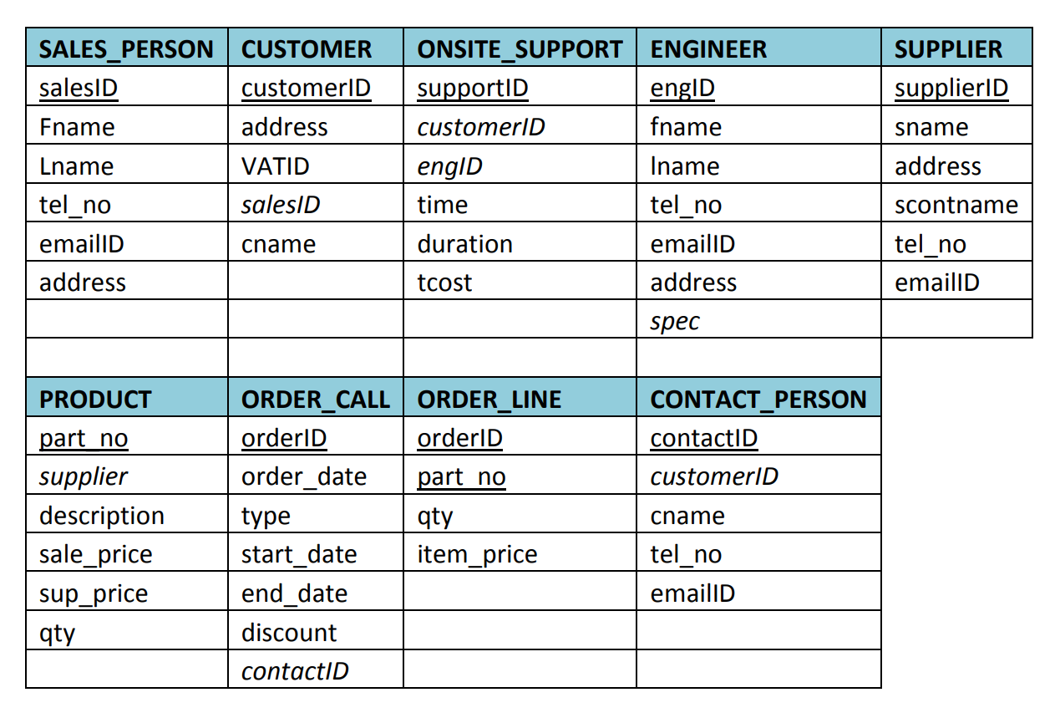
Question 7: Draw a Data Dictionary illustrating the information you have identified in Question 6.
DATA DICTONARY DIAGRAM HERE:
Object (Entity) | Name (Attribute) | Type  (Data type) | Description | Primary Key | Foreign Key
Salesperson | Sales_id | Number(not null) | Unique identification number of salesmen | Yes | No
 | Fname | Varchar2(30) | First name of salesmen | No | No
 | Lname | Varchar(30) | Last name of salesmen | No | No
 | Tel_no | Varchar(15) | Phone number of salesmen | No | No
 | Email_id | Varchar2(30) | Email id of salesmen | No | No
 | Address | Varchar2(50) | Location of salesmen | No | No
Customer | Customer_id | Number(15) | Unique identification number of customer | Yes | No
 | C_address | Varchar2(50) | Address of customer | No | No
 | Vat_id | Varchar2(10) | VAT ID as per company rules | No | No
 | Sales_id | Number(10) | Reference to table salesmen | No | Yes
 | C_name | Varchar2(30) | Name of customer | No | No
Contact Person | Contact_id | Number(15) | Unique identification number of contact person | Yes | No
 | Customer_id | Number(15) | Reference to table customer | No | Yes
 | Cp_name | Varchar2(50) | Name of contact person | No | No
 | Tel_no | Varchar(15) | Phone number of contact person | No | No
 | Email_id | Varchar2(30) | Email id of contact person | No | No
Supplier | Supplier_id | Number(10) | Unique identification for supplier | Yes | No
 | S_name | Varchar2(30) | Company name of supplier | No | No
 | S_address | Varchar2(50) | Address of supplier | No | No
 | Scontname | Varchar2(30) | Name of supplier | No | No
 | Tel_no | Varchar(15) | Phone number of supplier | No | No
 | Email_id | Varchar2(30) | Email id of supplier | No | No
Product | Part_no | Number(10) | Unique identification for product | Yes | No
 | Supplier_id | Number(10) | Reference to table supplier | No | Yes
 | Description | Varchar2(30) | About the part | No | No
 | Sale_price | Number(10,2) | Sale price of part | No | No
 | Sup_price | Number(5,2) | Supplier sale price of part | No | No
 | Qty | Number(5) | Number of parts taken | No | No
Engineer | Eng_id | Number(10) | Unique identification for engineer | Yes | No
 | Fname | Varchar2(30) | First name of engineer | No | No
 | Lname | Varchar2(30) | Last name of engineer | No | No
 | Tel_no | Varchar(15) | Phone number of engineer | No | No
 | Email_id | Varchar2(30) | Email id of engineer | No | No
 | Address | Varchar2(50) | Address of engineer | No | No
 | Spec | Number(10) | Reference to table Product | No | Yes
Onsite support | Support_id | Number(10) | Unique identification for support | Yes | No
 | Customer_id | Number(15) | Reference to table customer | No | Yes
 | Eng_id | Number(10) | Reference to table engineer | No | Yes
 | Time | Timestamp | Gives the timer of generation | No | No
 | Duration | Number(2) | Duration of support | No | No
 | Tcost | Number(10,2) | Total cost for the support | No | No
Order call | Order_id | Number(10) | Unique identification for order | Yes | No
 | Order_date | Date | Date of order | No | No
 | Type | Number(1) | Type of order | No | No
 | Start_date | Date | Date of start of order | No | No
 | End_date | Date | Date of end of order | No | No
 | Discount | Numbr(3) | Percentage of discount | No | No
 | Contact_id | Number(15) | Reference to table contact person | No | Yes
Order line | Order_id | Number(10) | PK & FK | Yes | Yes
 | Part_no | Number(10) | Reference to table product | No | Yes
 | Quantity | Number(5) | No. of items | No | No
Type | Type_id | Number(10) | Unique identification for type | Yes | No
 | Name | Varchar2(15) | Name of type | No | No

References:
Reference of entities & attributes from other companies database
Submission Date: 17th Jan 2022
--------------------------------------------END OF PROJECT----------------------------------------------
-------------------------------------------------Thank You-----------------------------------------------------

